**Steps to run the project**

**Group 1**

*Starting Backend*

* Download the compressed project from the given GitHub Link: [Github](https://github.com/harsh1x4/TECHBEE_JFM22_FS_JAVA_5_Restaurant_management_system.git)
* Open the Zira Backend folder and import the Zira folder into Eclipse IDE.
* The whole project is made using MySQL as a database. You can change the driver to run it on an Oracle Database as well.
* Open src/main/resources and go to your application properties and change the credentials according to your system.
* You can change the port number given in the application properties. If this port number is busy, then change the port number.
* Open src/main/java and open the package com.zira.restaurant and open the file ZiraApplication.java.
* Right click on the open editor of ZiraApplication.java and Run as Spring Boot Application.

*Starting Frontend*

* Open the Zira Frontend folder in VS Code.
* Open Terminal in VS Code and type ng serve.
* If it shows that the port is already in use. Use this command : ng serve –port 4400
* Go to the link given in the terminal and hold ctrl and click it.

***Credentials of Admin Module***

*Admin Username :* [ZiraAdmin@gmail.com](mailto:ZiraAdmin@gmail.com)

*Admin Password :* MRVKgQWrgARTzuV7

***Credentials of User Module***

*User Username :* harsha@gmail.com

*User Password :* Harsh@123

***Restaurant Deployment Manual***

The Project Restaurant Management System is divided into two main modules and sub modules.

1. *User Module* 2) *Admin Module.*
2. **Admin Module**

* The Application starts on this below page ZIRA Restaurant

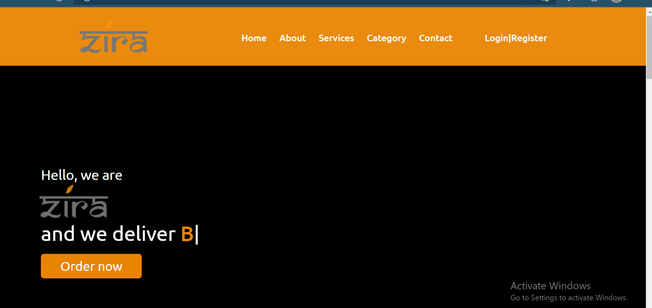

Here at first the user have to LOGIN or SIGNUP to access our services.

As shown below

*Login Form*

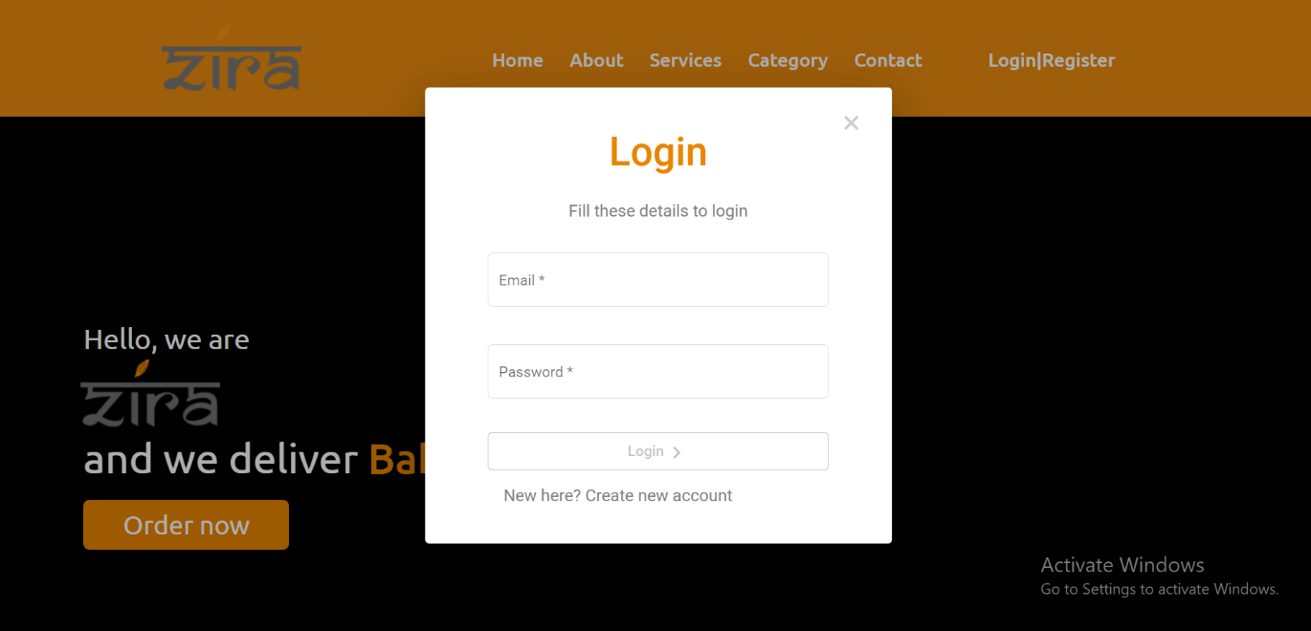

*Sign Up Form* 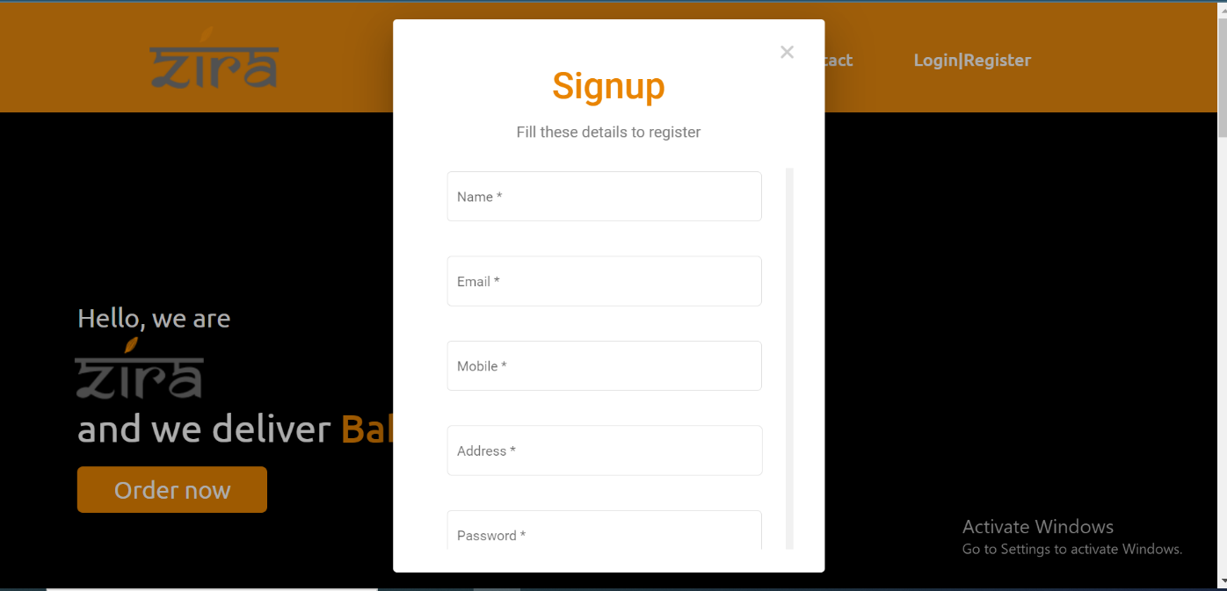

Here User can see our menu and can see the prices of our dishes.

User can search for the required dish they want to order on the search bar.

***MENU***

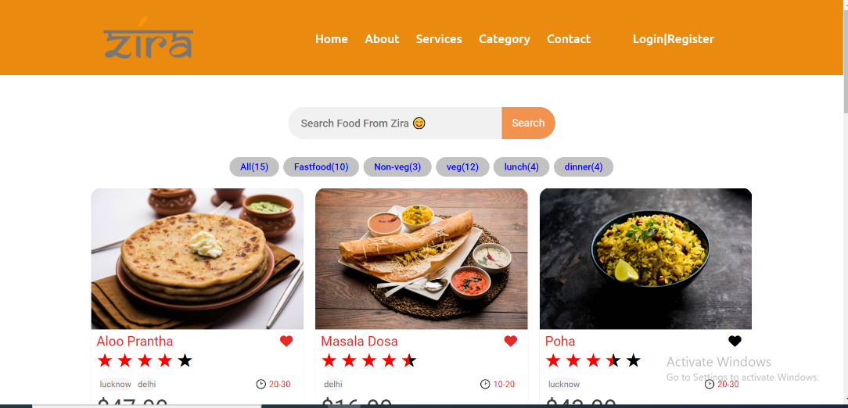

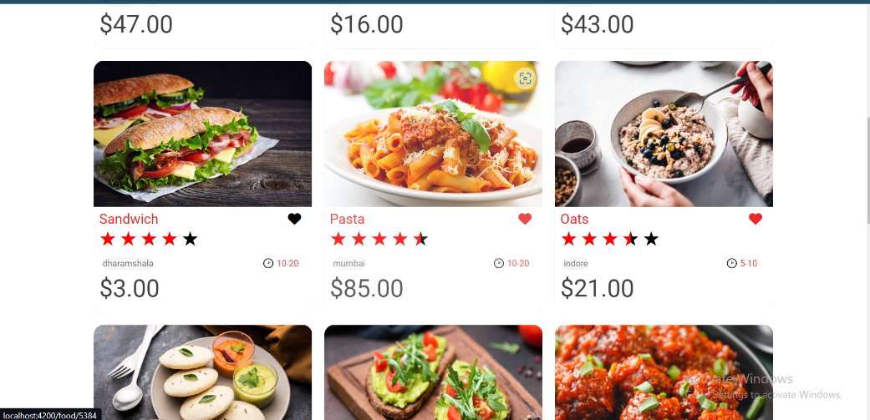

After clicking on particular dish below page will be displayed.

*Dish pricing and rating*

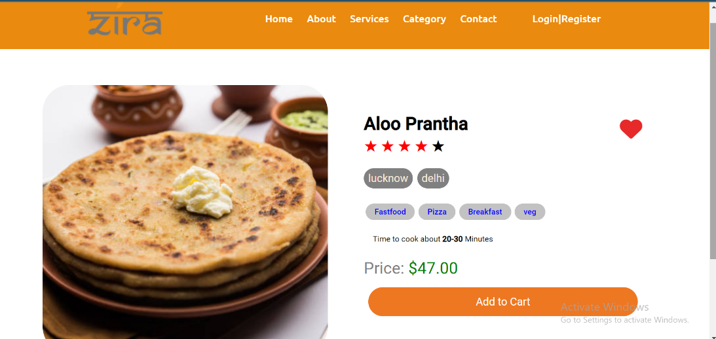

User can see the ratings and

***ADMIN MODULE***

These pages are only displayed to the Admin who can update or change the Menu, Staff, and Inventory and manage his/her restaurant on clicks.

*This is the Admin dashboard*

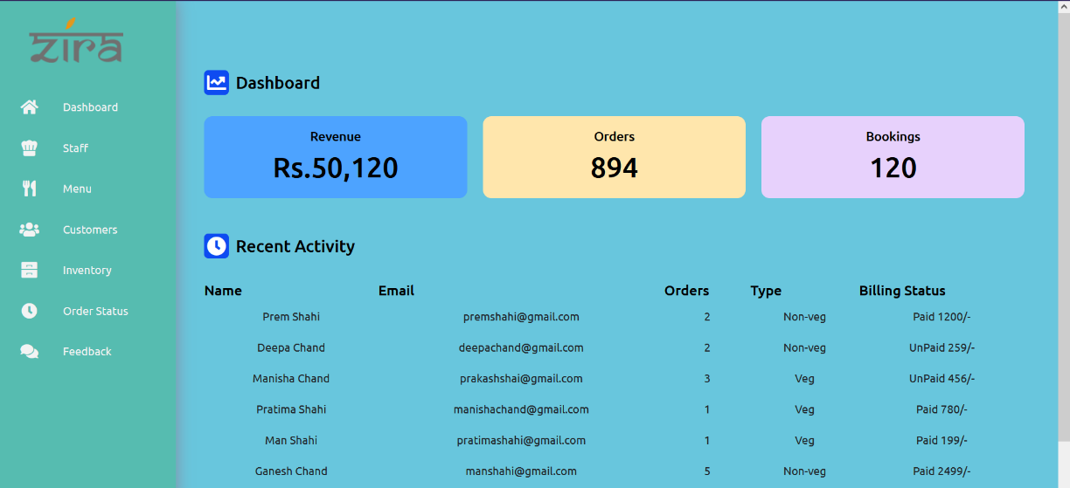

We have navigation bar on the left where the admin have following options as displayed on the screenshot above.

1. *STAFF*

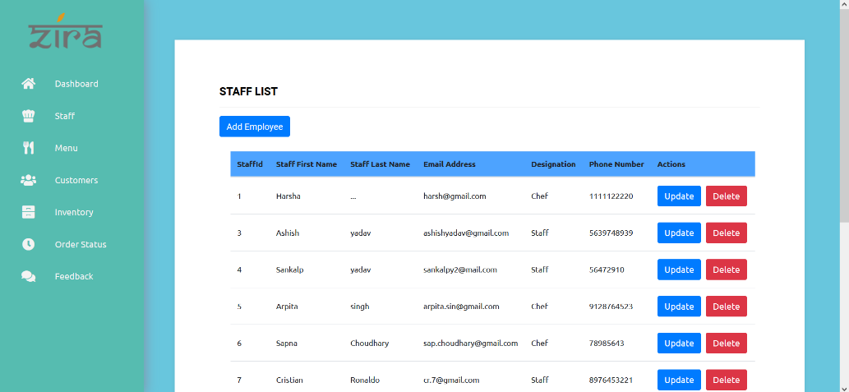

The Admin can update and delete the staff details as displayed on the screen shot below.

Add Staff

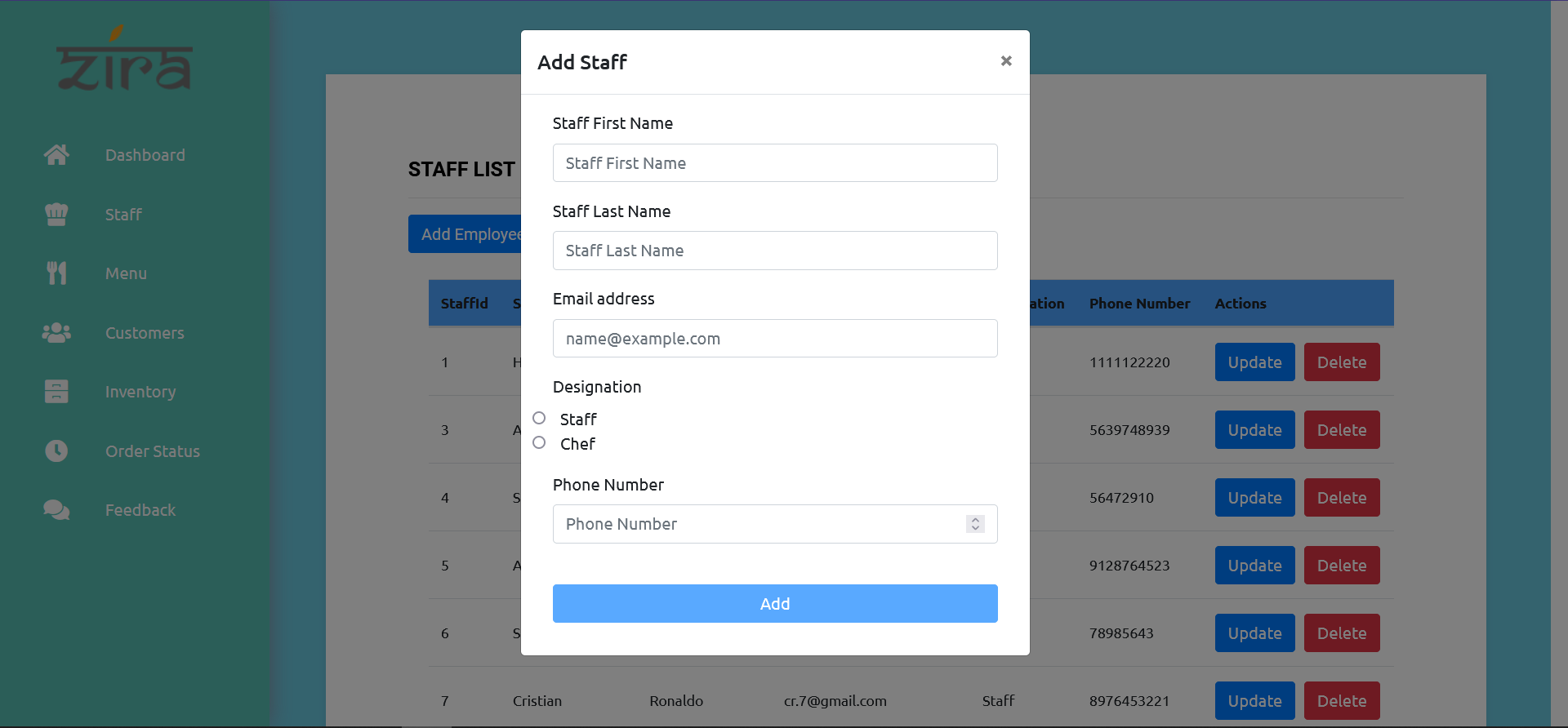

Update Staff

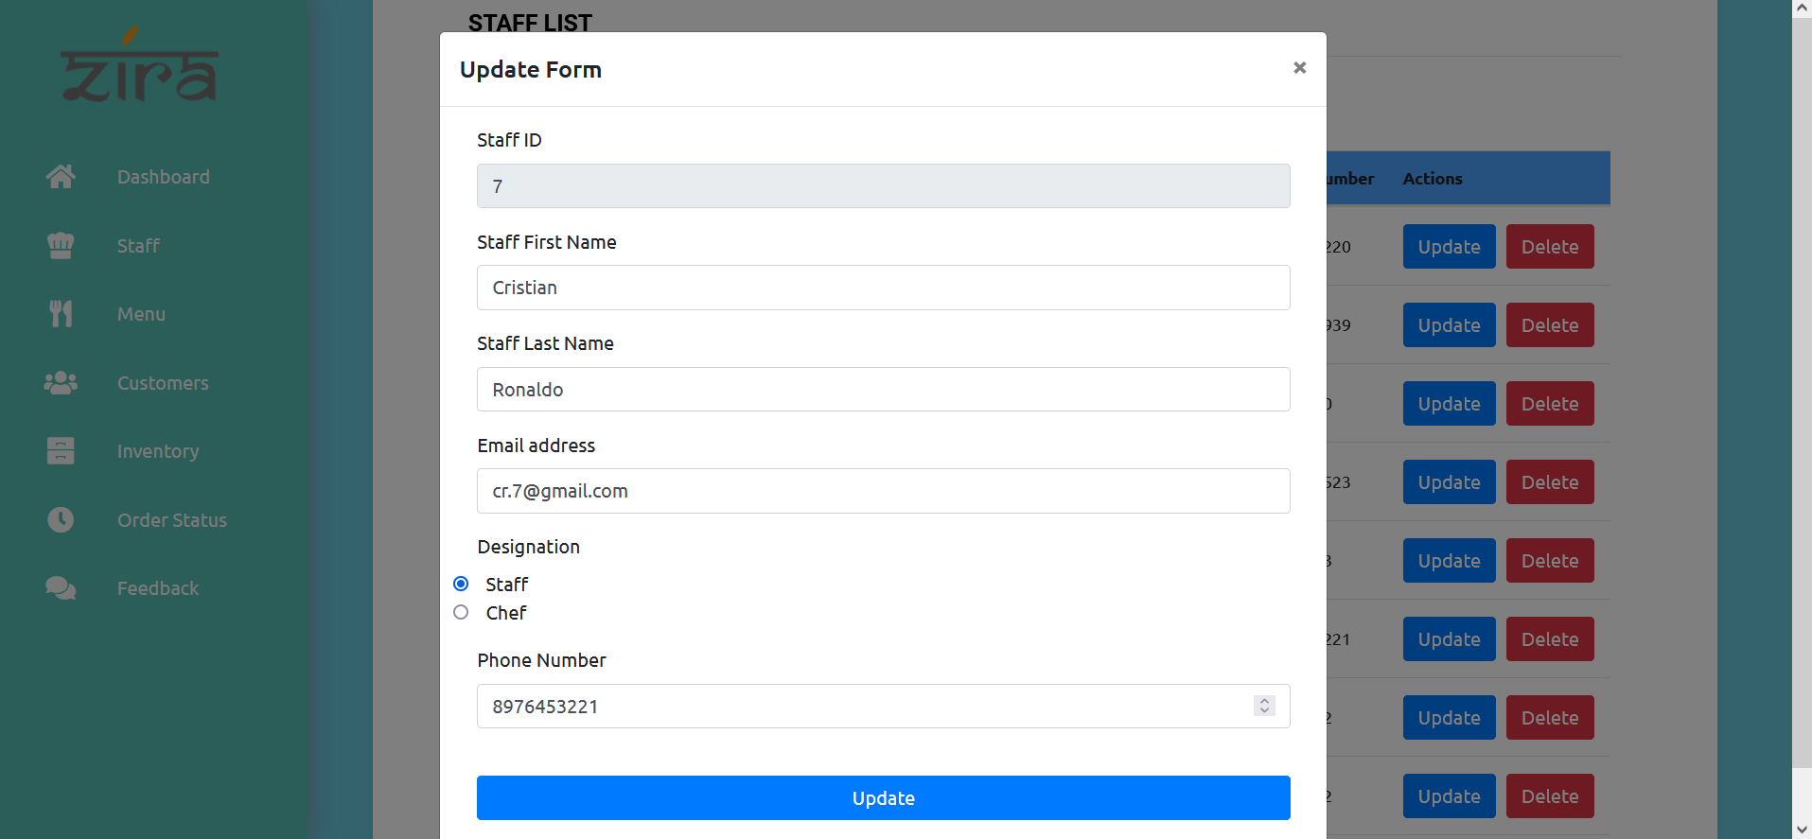

*2)Menu*

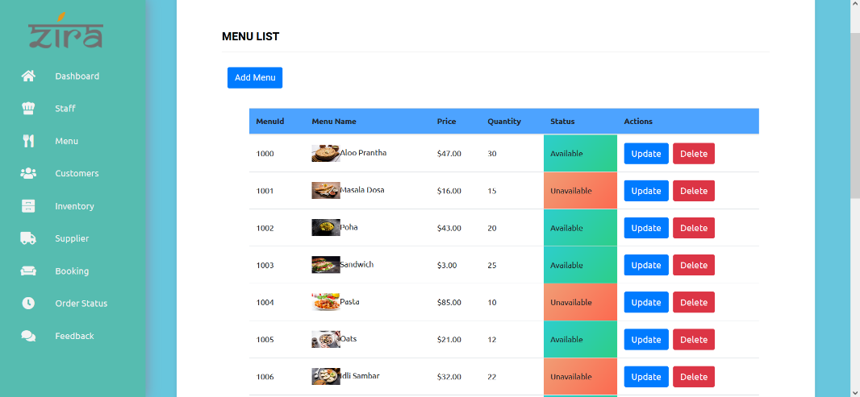

Here the ADMIN can change the menu as per the wish, by attaching the URL of the image to be displayed.

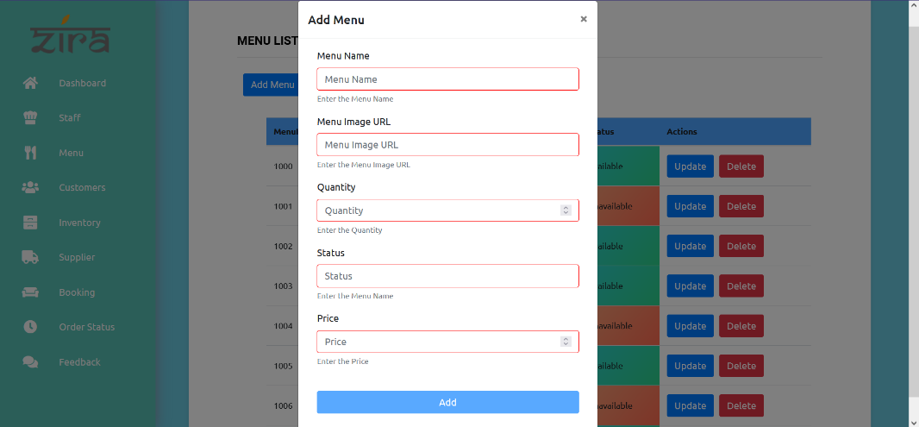

Same as Menu we have Inventory & Supplier delete/update pages.

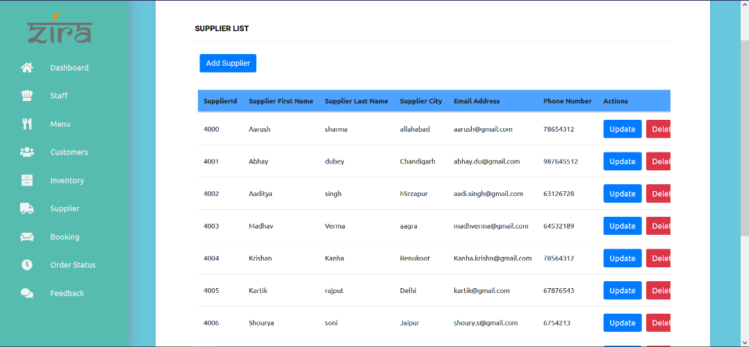

Inventory list is all about food supplies available in stock.

